**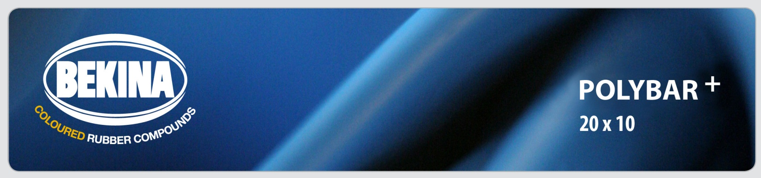**

**TECHNICAL DATA SHEET (TDS)**

**Hydrophilic water stop based on synthetic rubber that acts as watertight seal for construction joints with excellent swelling capabilities. Retains its own form in adhesive.**

|  |
| --- |
| **USE** |
| * Designed for the easily applied sealing of construction joints in concrete and reinforced concrete construction. POLYBAR+ seals against non-pressing and pressing ground water up to 6 bar. POLYBAR+ can be used in repeated wet and dry cycles. |
| * The joints should in all instances be square butted and tight to ensure a continuous section with a minimum of 60mm concrete cover. |
| * POLYBAR+ can be applied both vertically and horizontally but under no circumstances should it be used in expansion joints. |

|  |
| --- |
| **Description** |
| * Swellable water stop based on synthetic rubber as watertight seal for construction joints with excellent swelling capabilities. POLYBAR+ retains its own form in multiple wet and dry cycles. |
| * POLYBAR+ has good resistance to a wide range of chemicals – although we would always recommend final confirmation as to suitability in contaminated circumstances be obtained from our technical dept. |
| * The product remains consistent in its performance throughout its life cycle and the flexibility allows it to fill voids and cracks in the immediate surrounding area. |

|  |
| --- |
| **APPLICATION** |
| * Can be mechanically fixed with nails at approx 300mm centres or adhered with adhesive. |
| * The product can be adhered to concrete, steel and PVC pipe penetrations with the adhesive. |
| * The adhesive will also ensure a good bond is achieved on slightly uneven surfaces. |
| * The use of a tying wire around POLYBAR+ in the case of securing it to PVC pipes is also recommended in conjunction with the adhesive. |
| * For salt water environment, in polluted water conditions and in contact with manure and slurry, we recommend POLYBAR+ Salt (See separate TDS). |

|  |  |
| --- | --- |
| **TECHNICAL DATA** |  |
| Swelling capacity in concrete water | 400% |
| Swelling capacity in rain water | 500% |
| Colour | Blue |
| Hardness | 35° Shore A |
| Tensile strenght | >2 MP a |
| Elongation | >400% |
| Density | 1,22 +/- 0,03 |
| Temperature range | -20 +75°C |
| Weather resistance | Excellent |
| Chemical resistance | Good overall chemical resistance, but we advise to be careful with aromatic oils and fuels, with vegatal oils and strong aromatic solvents. Contact our sales department for detailed specific information. |

|  |  |  |  |
| --- | --- | --- | --- |
| **Sizes and packaging  F:\BEKINA-COMPOUNDS\MARKETING\BASISMATERIAAL\FOTOS_Etiketten\20x10.jpg** | | | |
| Size | Roll | In a box | Boxes / pallet |
| 20 x 10 mm | 10m | 9 x 10m | 24 |

|  |
| --- |
| **Certificates** |
| Detailed reports and certificates available on request at info@bekina-compounds.be |

|  |
| --- |
| **SAFETY** |
| The safety datasheet is available on request at info@bekina-compounds.be |